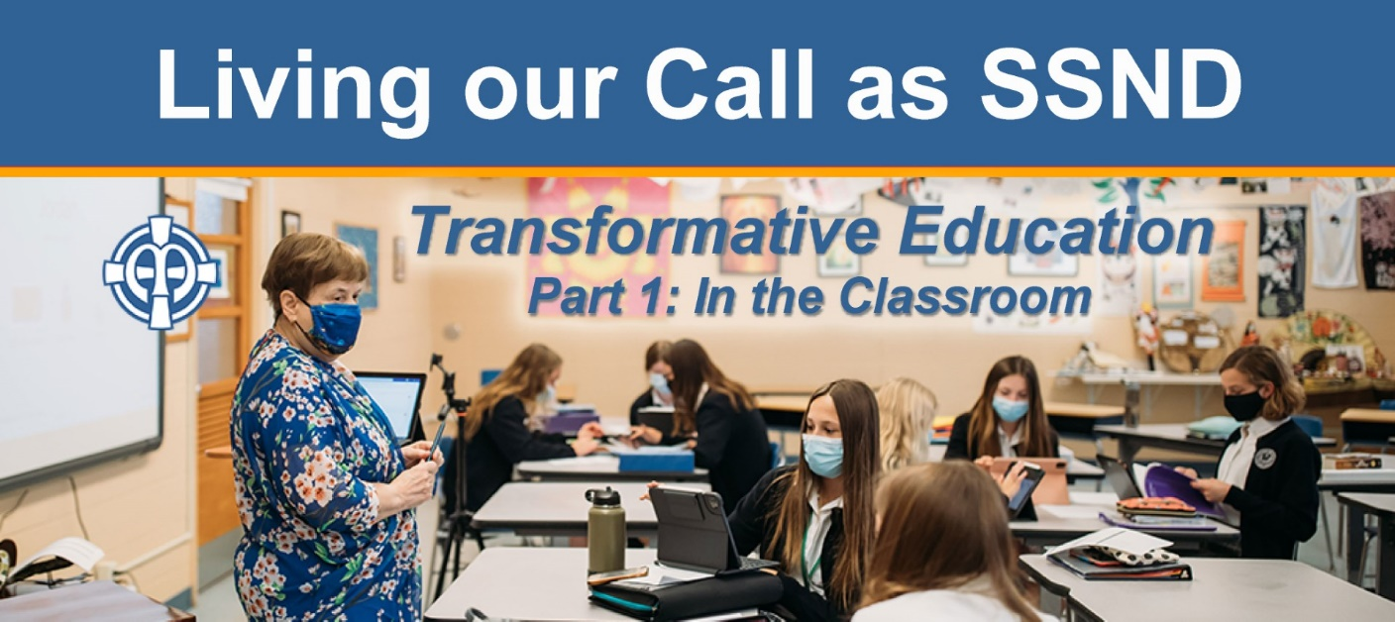

Bulletin/Newsletter Announcement
Living Our Call as SSNDs: Transformative Education, Part 1 – In the classroom
The School Sisters of Notre Dame (SSND) North American Vocation Team invites women ages 18-45 to this first of a three-part online series about our call as educators and the educational vision that frames it. Part I will begin Thursday, October 14, 2021 at 7 p.m. CT and will focus on our SSND educational vision as it relates to formal education. Hear from Sisters ministering at SSND sponsored educational institutions: Notre Dame School of Milwaukee, Notre Dame High School in St. Louis, and Notre Dame of Maryland University. Learn more and register for the Zoom link at ssnd.org/events/10-14-21/.
Alternative image:
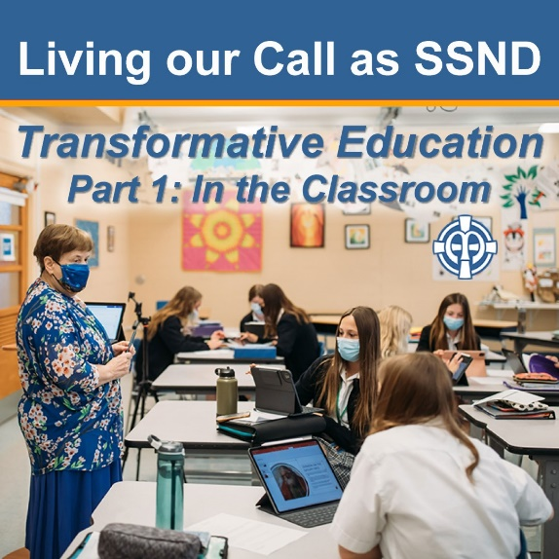

Questions? Contact Laurie Lindauer, SSND Communications Manager, at llindauer@ssnd.org.

