Our Deeper Memory Retreat
REGISTRATION FORM, 2018 (Please Print)
NAME ______________________________________________________________________________________
ADDRESS ___________________________________________________________________________________
CITY __________________________________________________ STATE ______________ ZIP ____________
Home phone (_____) ____________________________ Work phone (_____) _____________________________
Email address _________________________________________________________________________________
Transportation assistance needed? _____ Plane _____Train _____Other (please send details)

Send registration and $50 deposit to OLPR (Our Lady of the Prairie Retreat) 820 W Central Park Ave Davenport IA 52804
Make check payable to OLPR .
------------------------------------------------------------------------------------------------------------------------------------
Dates and Times:
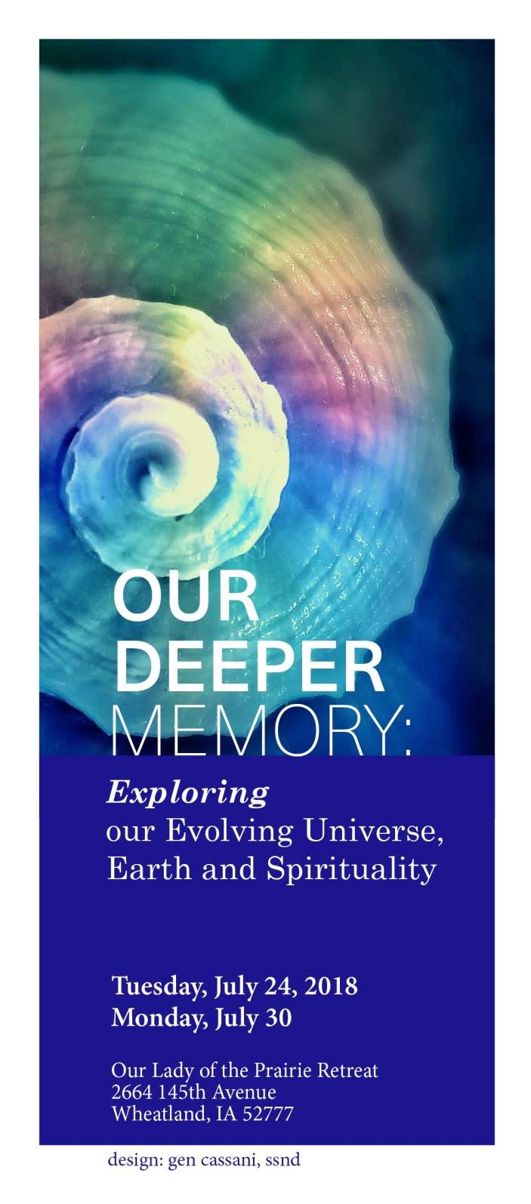
Tuesday, July 24, 2018 (5 pm with dinner) Monday, July 30 (11 am after brunch)

Cost:
$500 which includes $50 nonrefundable deposit sent with registration. Balance of $450 due upon arrival.

Registration deadline is June 9, 2018.
Retreat is limited to ten participants.

Facilitators:
Kathleen Mary Kiemen, SSND
Former Co-Director of the
Center for Earth Spirituality and Rural Ministry
Maxine Pohlman, SSND
Director of La Vista Ecological Learning Center
Paulette Zimmerman, SSND
Former team member of the SSND Justice, Peace and
Integrity of Creation Staff, Central Pacific Province
For More Information:
Facilities Retreat Content
Marcia Eckerman, CHM Kathleen Mary Kiemen, SSND 563-374-1092 651-528-8724 marciaechm@yahoo.com kkiemenssnd@yahoo.com

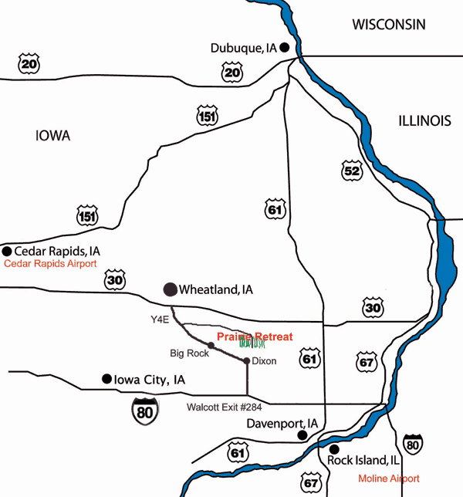
Exploring who we are in the original root of our being

Exploring who we are in the original root of our being

This silent retreat includes morning rituals and presentations, time to commune with nature in this pristine habitat, supportive videos and an optional sharing each day. Retreat concludes with a hermit day outdoors with Earth.
Presentations will explore the deep memory of

- the universe, Earth, and ourselves
- feminist, indigenous and Celtic spiritualities
- Jewish and Christian traditions
- our local bioregions

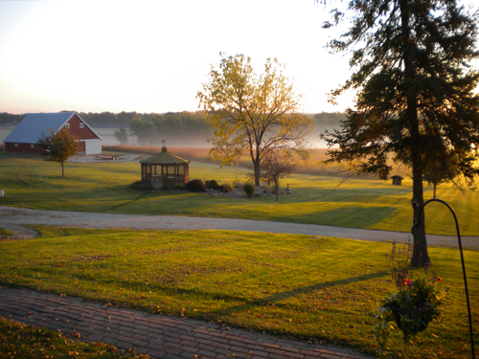
Presentations include:
- Birthing a New Universe Story that encourages a shift to a biocentric spirit and focus
- Exploring the Nature of the Universe in its Guiding Principles and Characteristics that will guide us to a wholistic and feminine relationship with all life
- Participating in a Council of All Beings
- Gleaning wisdom from Laudato Si and the writings of Thomas Berry
- Living the New Universe Story as an
Our Lady of the Prairie Retreat
is a ministry of the Congregation of the Humility of Mary, located in rural east central Iowa on a 200-acre native prairie grass woodland along the Wapsipinicon River. The Prairie offers quiet beauty conducive to personal prayer and reflection. Includes: a 2.5 mile cosmic walk, outdoor labyrinth, pond, 130 acres of rolling prairie grasses, 30 acres of woodland, and accessible rooms. Food is grown organically at The Prairie. All meals are vegetarian. Consult with us about special dietary needs.

Contemplating the beauty of our deepest identity as blessed human beings in an ancient universe on our sacred Mother Earth will guide us into action on behalf of the whole Earth community.
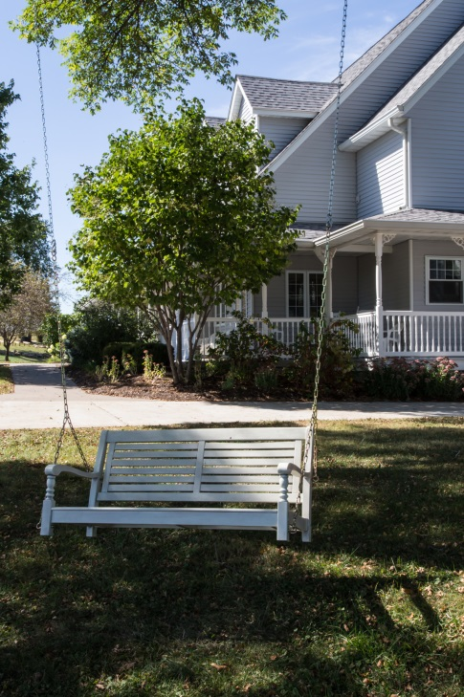
Retreat into conscious transformation of heart and soul by…
Additional Information:
- Our Lady of the Prairie has a 2.5 mile cosmic walk, outdoor labyrinth, pond, 130 acres of rolling prairie grasses, 30 acres of woodland, a handicapped accessible room.
- Meals are vegetarian. Please provide for your own special dietary needs.

- Deepening an awareness of the Universe as the primary revelation of the Divine
- Awakening a

At the heart of our being is the image of God, and thus the wisdom of God, the creativity of God, the passions of God, the longing of God.

John Philip Newell

We shall awaken from our dullness and arise vigorously toward justice. If we fall in love with creation deeper and deeper, we will respond to its endangerment with passion.
Hildegard of Bingen

